# **Police Station Management System Project in C++**

**Project Report By**

**Submitted By**

Shaikh Hashim Siraj

Shaikh Ashifaque Mustafa

Shaikh Sahil Imtiyaz

Shekh Mudassir

Under the guidance of

**Prof. D.Magar**

**(Lecturer, Comp Engg Dept.)**

## **Police Station Management System Project in C++ with Source Code**

The objective of the **Police Station Management System in C++** is to keep track of criminal records. A user must first log in to gain access to the main menu, after which they can manage criminal records by adding, updating, removing, viewing, and searching for information. This little project has only a few features, but they are all necessary.

## **About Police Station Management System Project in C++**

When it comes to the functions of the Police Station management system, the user can enter various criminal information. The user must give the convict’s id, name, age, gender, height, weight, crime, face details, conviction, and other information in order to do so. Aside from that, the user can search, amend, and delete records, as well as view/check a list of entries.

**Police Station Management System Project in C++ Information**

## **Features Available Police Station Management System in C++ Framework**

| **Admin Features Available** |
| --- |
| Add record |
| Modify record |
| Display record |
| Delete record |
| List of all record |
| Exit Program |

**Police Station Management System C++ Admin Features**

## **Police Station Management System in C++ Steps On How To Run The Project**

Time needed: 5 minutes.

Here’s the steps on how to run the **Police Station Management System Project in C++**

* **Step 1: Download G++ Compiler**

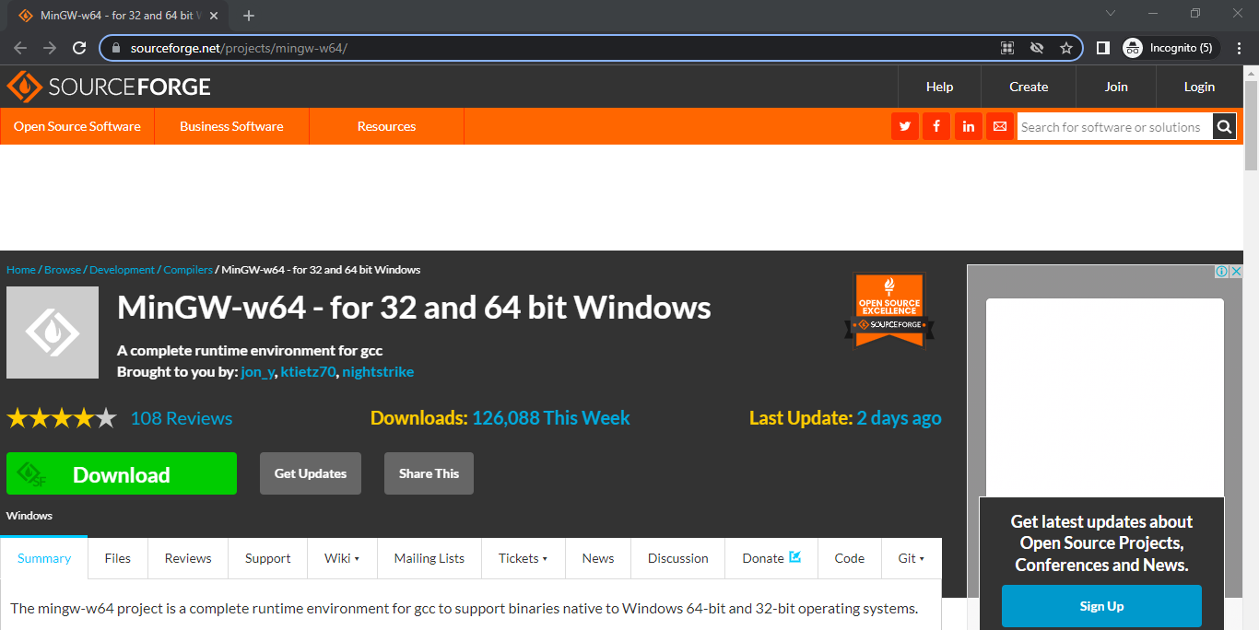First, To download the g++ compiler just click the link [here](https://sourceforge.net/projects/mingw-w64/).

* **Step 2: Open CMD and Compile**

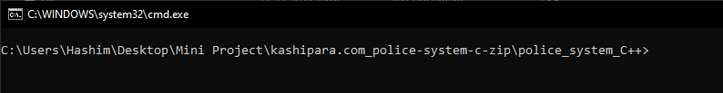Next, Open the command prompt(CMD) in your project folder directory.

* **Step 3: Compile Project**

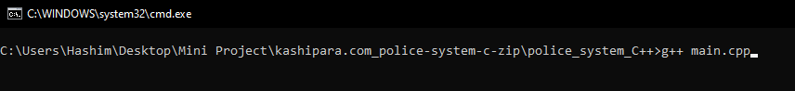Then, To compile, run the command to execute. – “**g++ main.cpp**“.

* 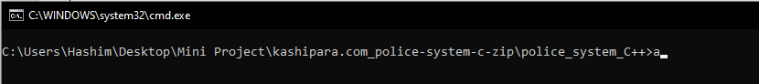**Step 3: Run Program**

After that, to run the program you need to execute the following command just type “**a**“.

* **Step 4: Output of the System**

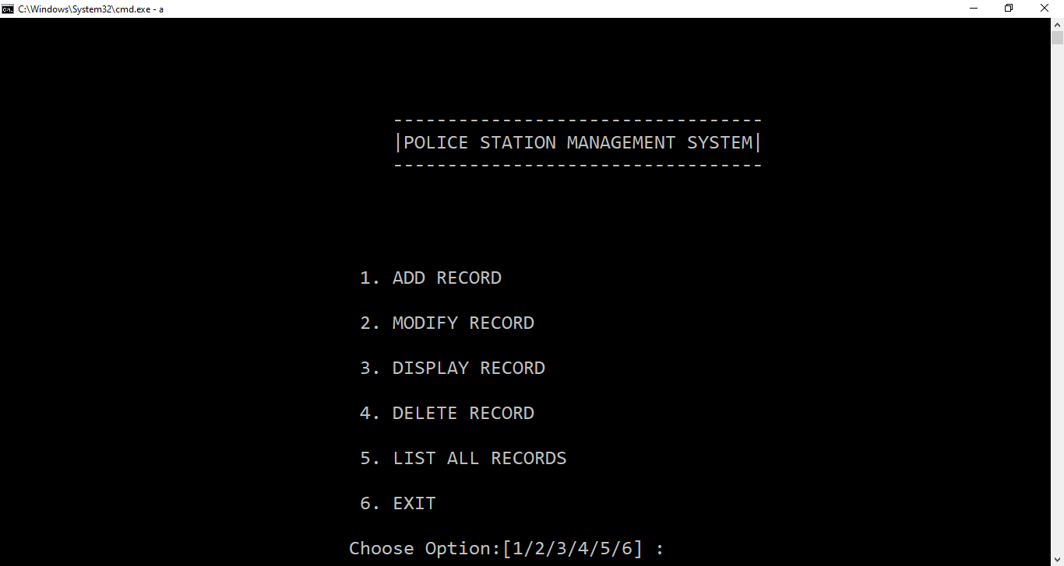Finally, the image below is the output of the running program of Police Station management system in C++.